* **Overview**

This document aims to provide guidance on creation of a software demonstration of a patient monitor. The demonstration is scheduled for April 19th, 2016. Below are rough drawings of a patient monitor as well as a screenshots of real-life monitors and some information that might be useful in development.

* **Mock Up**

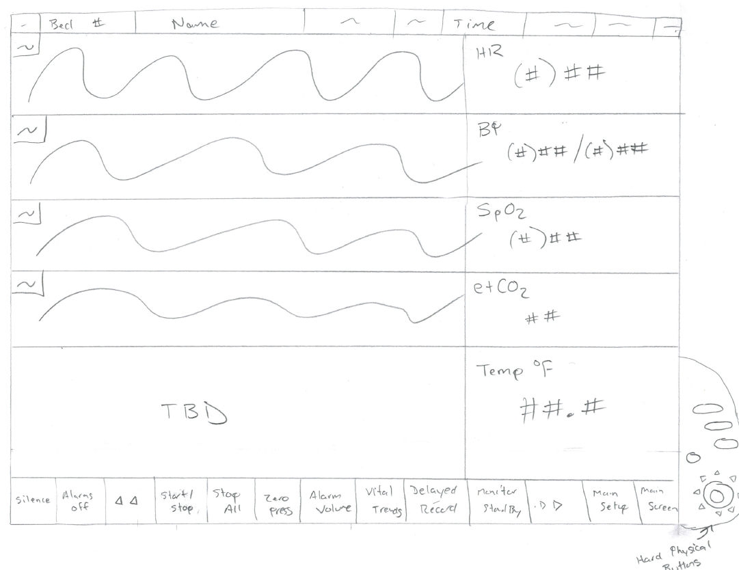

* **Real World Examples**

The patient monitor shall emulate the Phillips Intellivue MP70. Below is an image taken from an actual observation performed by an AHRQ team member. The quality is poor and a tentative trip is planned for April 6-8 to get a better screenshot.

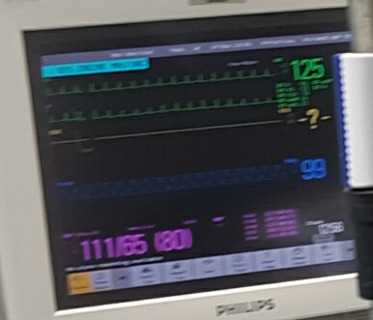

A video of a similar configuration Youtube can be found at [(MP70) Demo -Adult, Neonatal](https://www.youtube.com/watch?v=FTWXEcK1MVk).

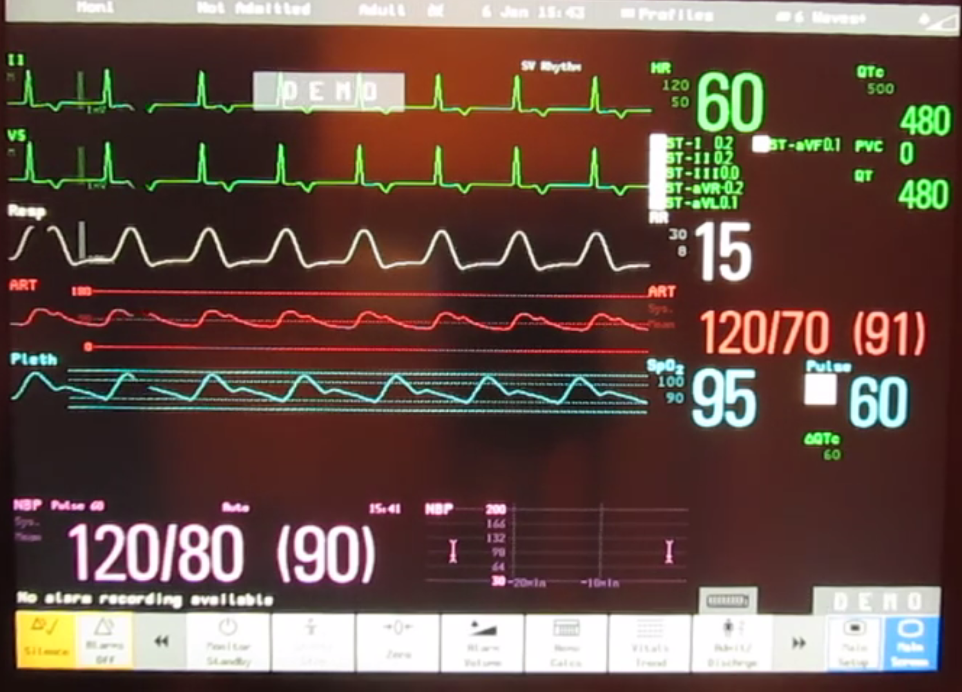

A foreign version here - <https://www.youtube.com/watch?v=aXmTcGbdT38>. You might be able to perform some more Google searches on Philips Intellivue MP70 to find others, but many have different configurations - <https://www.google.com/search?q=intellivue+monitor&num=30&source=lnms&tbm=isch&sa=X&ved=0ahUKEwjQ2pKG1NzLAhUDJx4KHQleAmkQ_AUICCgC&biw=1152&bih=547>

Anesoft (<http://anesoft.com/_files/demos/anesth6demo/anesthsim6-demo.html>) and Draeger (<http://www.draeger.com/sites/de_de/Pages/Hospital/product-trainer.aspx>) might have useful trainers to look at as well for maybe additional graphs and patient monitors if you can’t find enough on the Philips brand used here.

Additionally, alarm sounds and graph audible indicators can be recorded into wave files from Youtube in the video [Philips intellivue alarm sounds](https://www.youtube.com/watch?v=r8s21EZ9lVk) as they will likely be used at a later date or similar sounds created using a sound generator.

* **Moving Forward**

Suggest you consider being flexible and robust with your code where possible in case a change needs made at a later date.

Clinical users, including those coming on April 19th to view the demonstration, will be part of the project. They will eventually assess different technology in focus groups, review the validity of the results, and potentially participate in experiments in the future. This is why it is important to have the patient monitor be similar to a real-world one.

I tried to simplify the actual display from the real-life in my crude drawing. The physical buttons to the left are not necessary in this iteration of development right now. For the touchscreen buttons at the bottom, make them disabled except for the silence one.

For the 4 graphs, they may change in the future, but for now the concept will include the below. Some additional wording is added to aide in searching for information on how it should look. While all of them would be desirable to have programmed, the ECG and one other would be acceptable by the demonstration time. If you cannot program them all, try to have a static image represented on the display.

1. ECG / V2 / V_2 / II / ST-II *V5 is common I think too. Sometimes there are 2 small graphs in the space
2. ABP / Ambulatory Blood Pressure
3. Pulse Oximeter / Pulse Oximetry / Pleth / Plethysmograph / SpO2
4. Respiration / Resp

For the other parameters being monitored on the right and bottom side, I will admit I am not extremely knowledgeable on everyone. Just make some recommendations. Might include heart rate, NBP (non-invasive blood pressure) and mean arterial pressure (pink on picture), pulse, heart rate, respiratory rate, temperature, etc. The paramters should change slightly during the demonstration or according to alarms if appropriate.

The accuracy of the graph is nice, but it does not need to be perfect and I understand the difficulty with finding the waveform function needed to represent something like this. Use placeholders (your existing graphs) for the graphs for now and design the rest of the application.

The demonstration should be approximately 5 minutes. Generate 5 audible alarms where the user can silence them using the silence button. The Youtube video above has some example alarm sounds. Let us know which alarms you’d like to simulate. The “Lead’s off” ones are fine too and they will be easy since they have nothing to do with the physiological variables being monitored on the patient.